Contents

Screenshot1 2

Screenshot2 3

Screenshot3 3

Screenshot4 4

Screenshot5 4

Screenshot6 5

Screenshot7 6

Screenshot8 7

Screenshot9 8

Screenshot10 9

Screenshot11 10

Screenshot12 11

Screenshot13 12

Screenshot14 13

Screenshot15 13

# Screenshot1

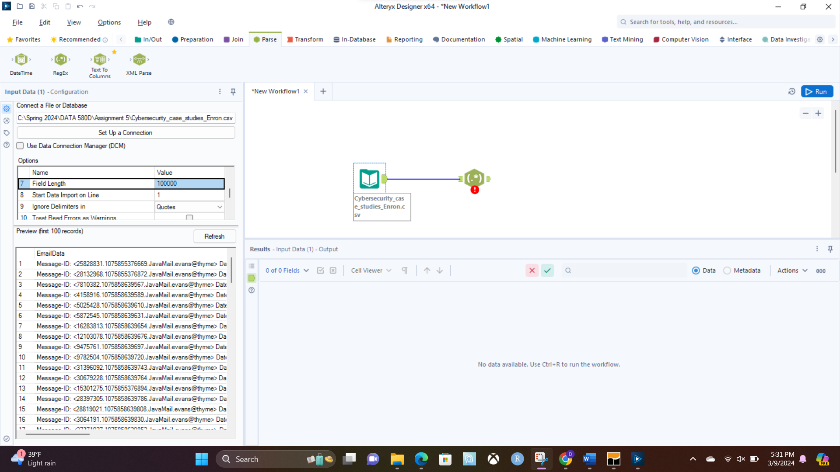

# Screenshot2

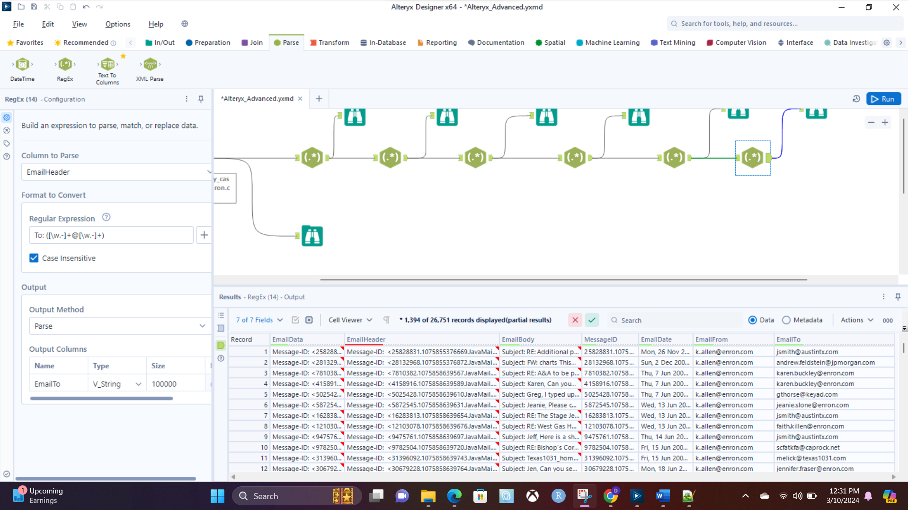

# Screenshot3

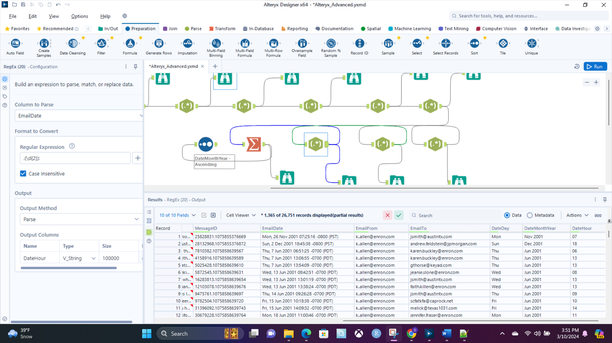

# Screenshot4

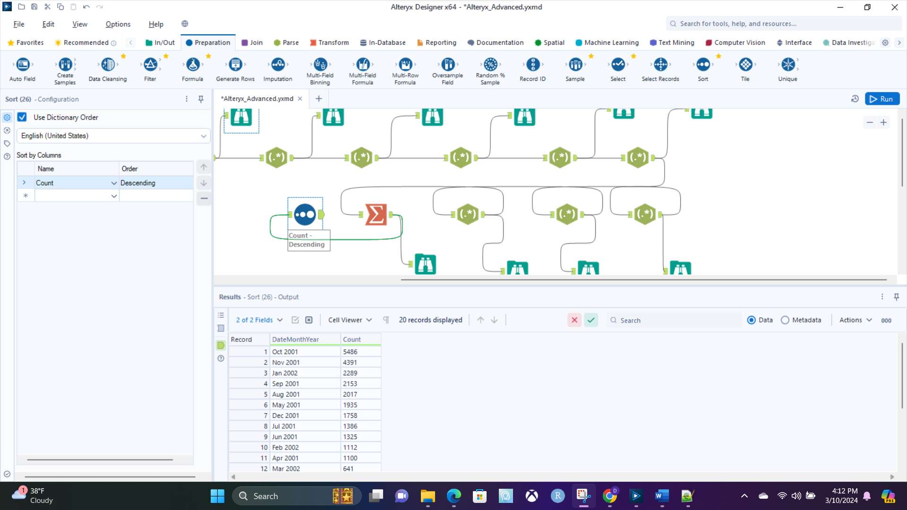

# Screenshot5

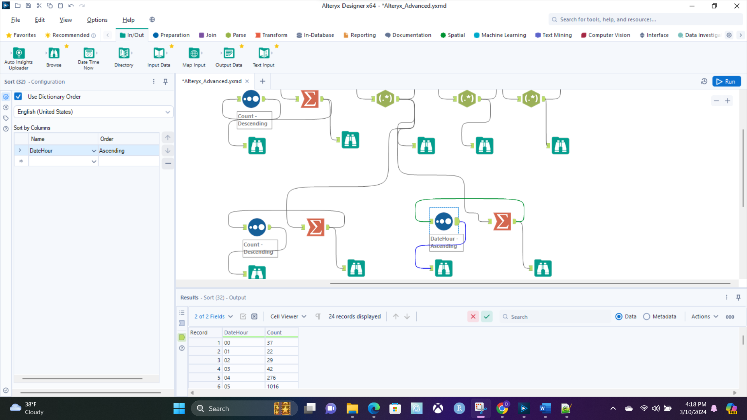

# Screenshot6

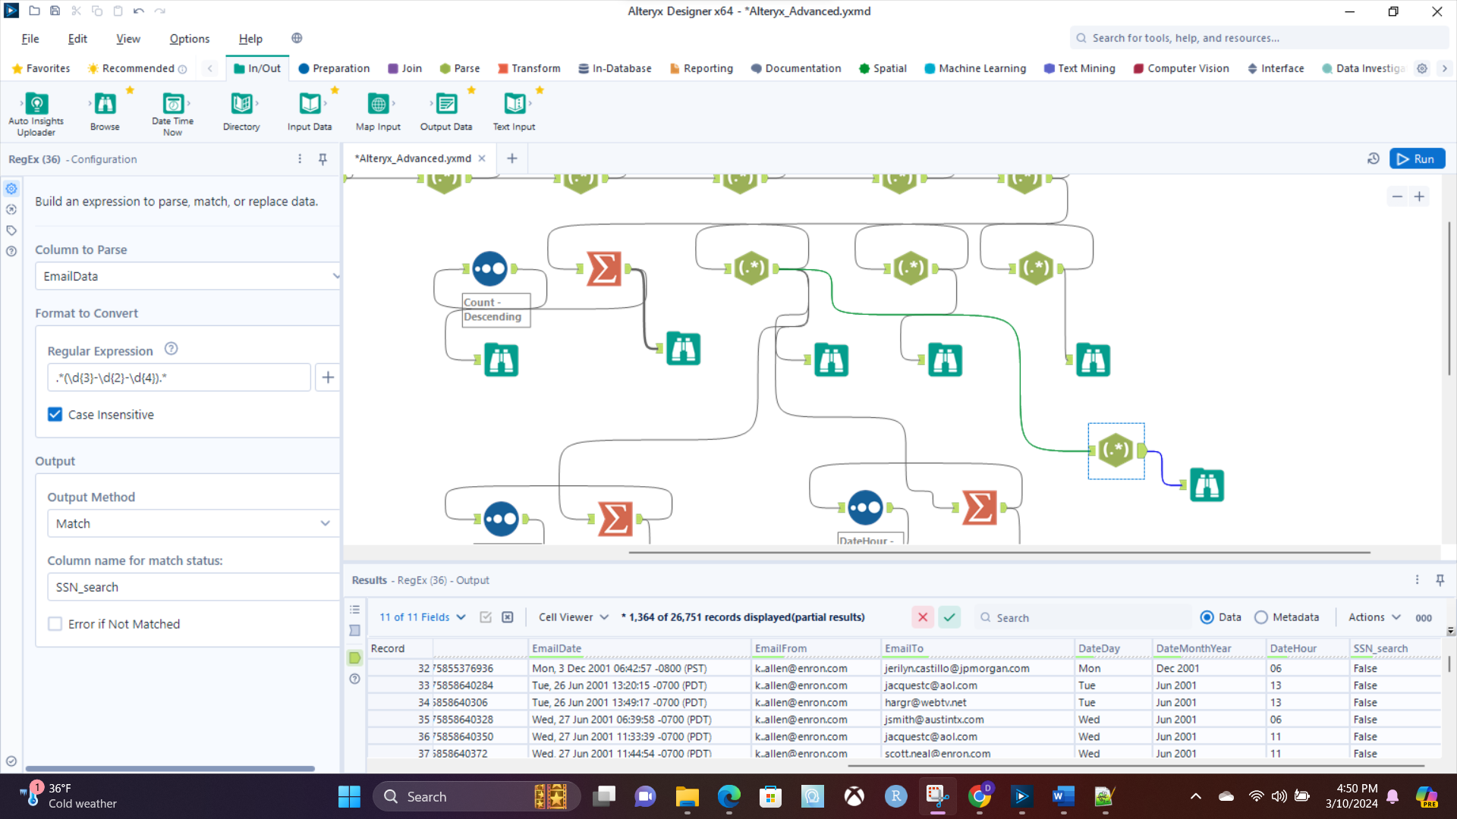

# Screenshot7

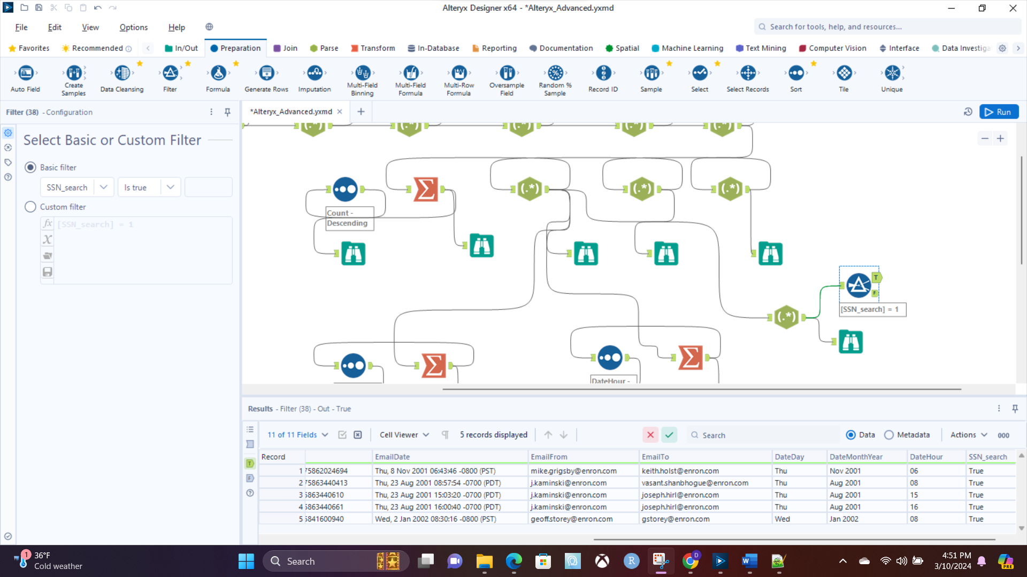

# Screenshot8

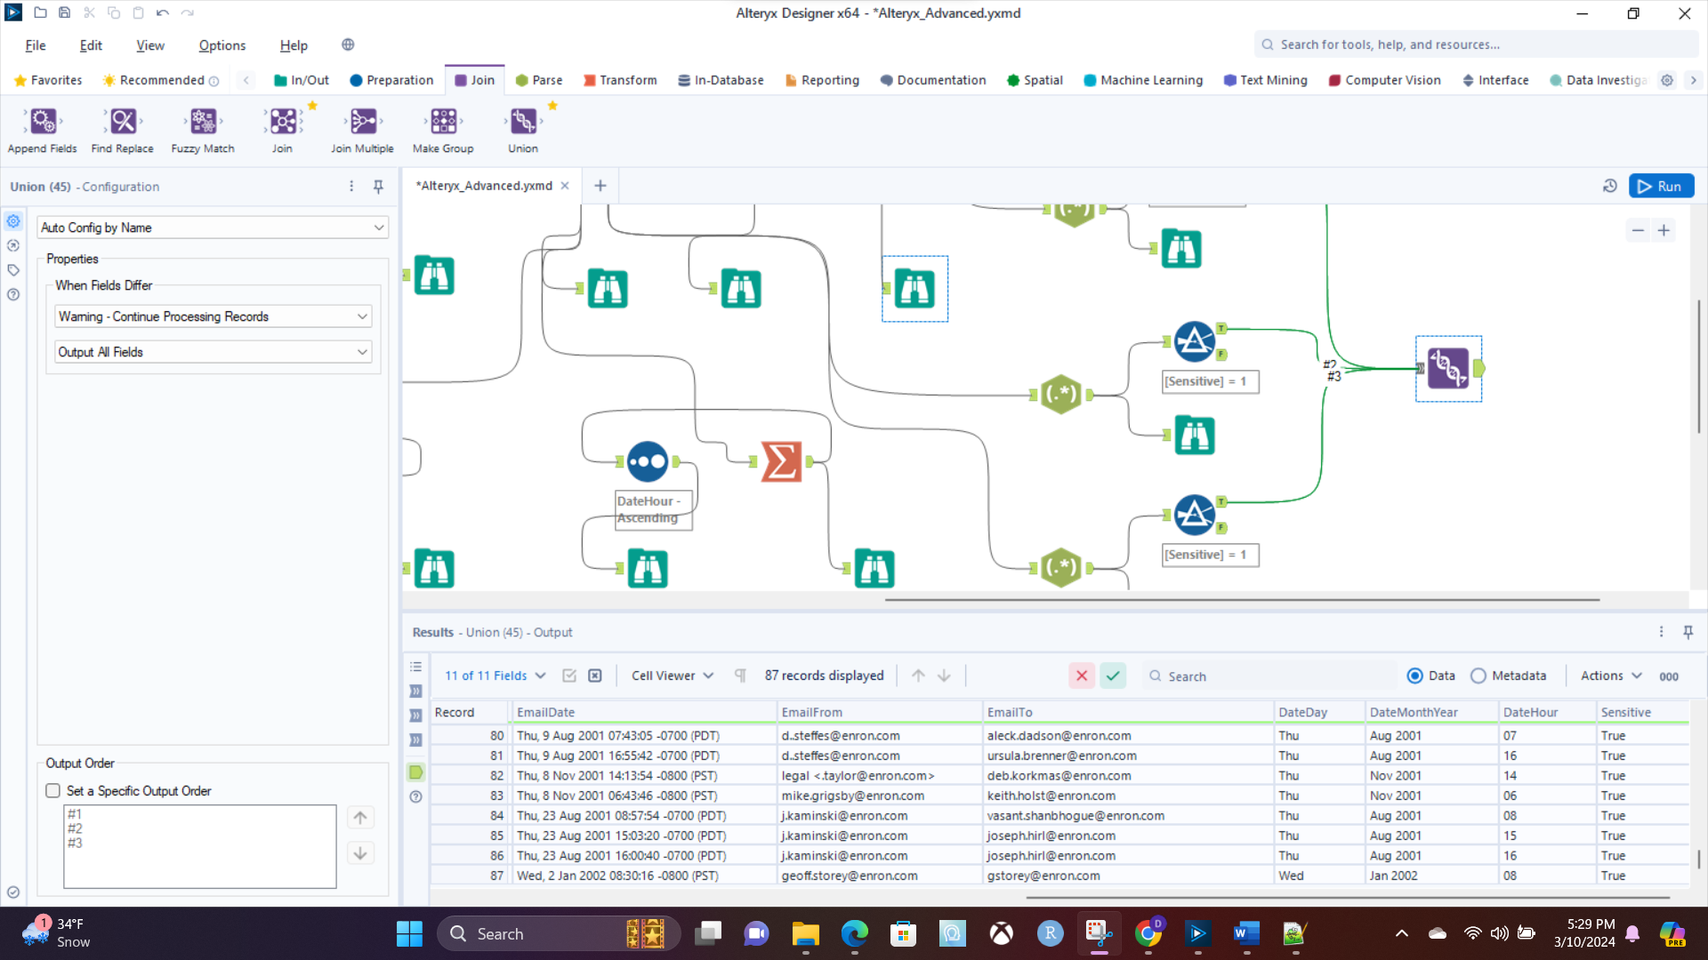

# Screenshot9

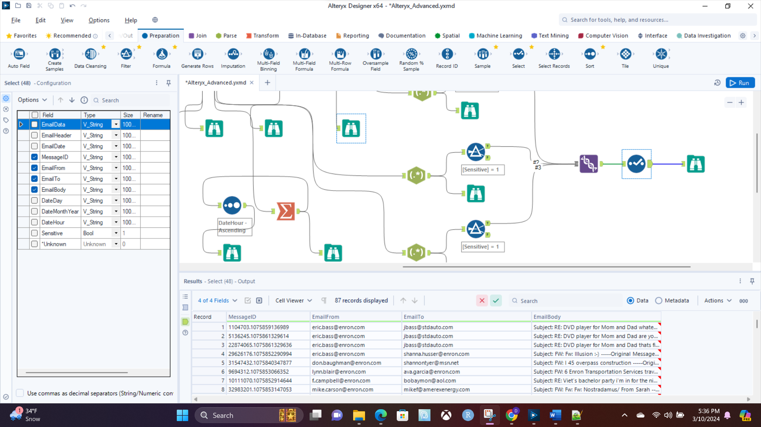

# Screenshot10

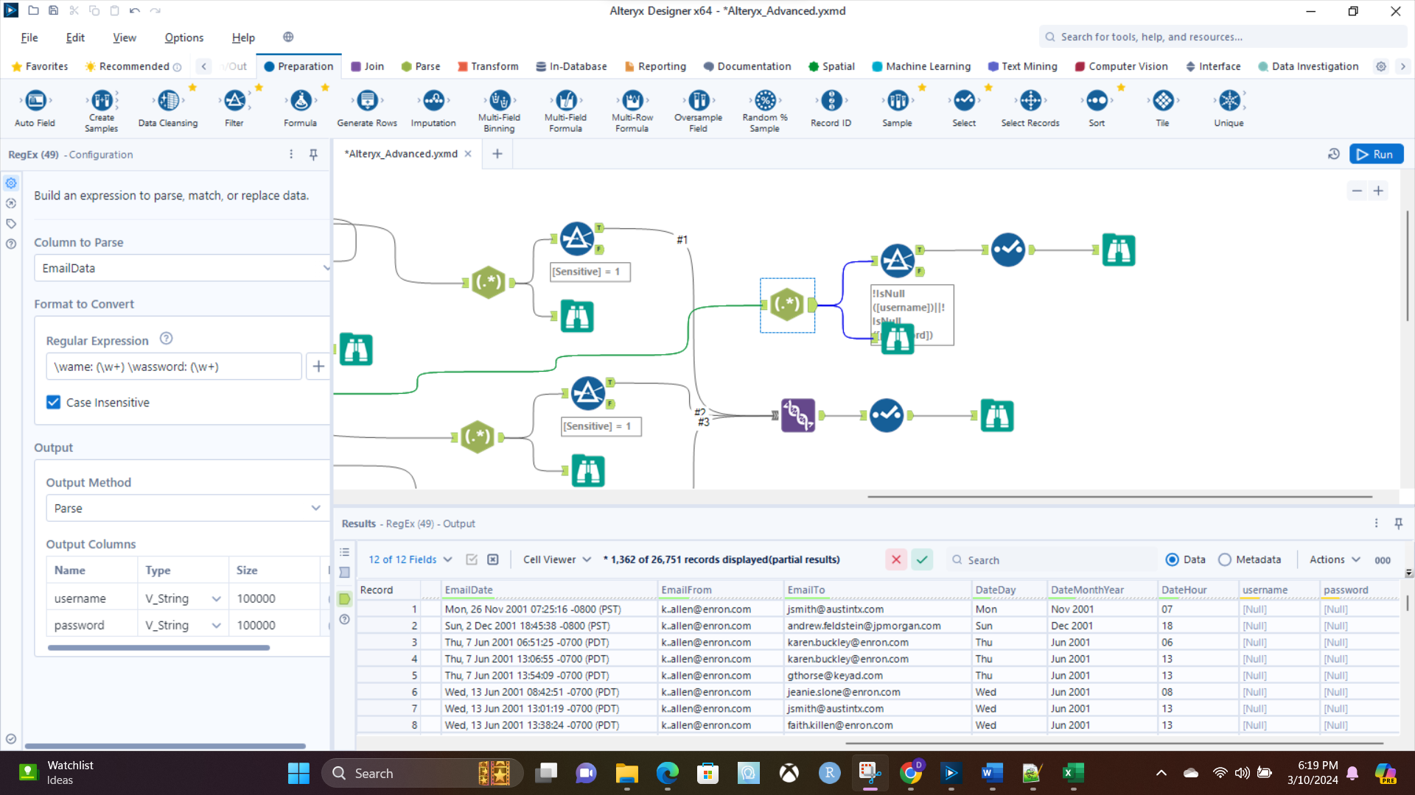

# Screenshot11

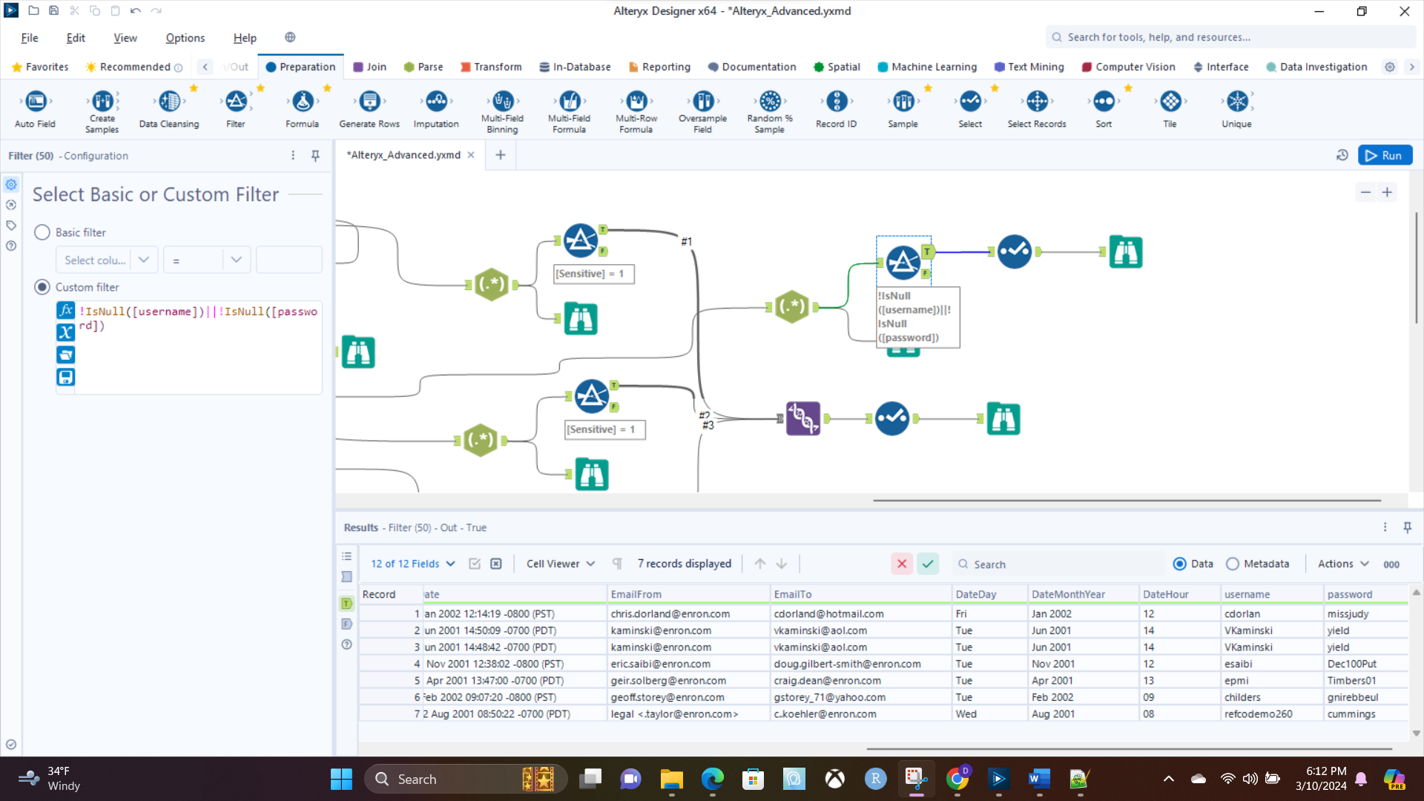

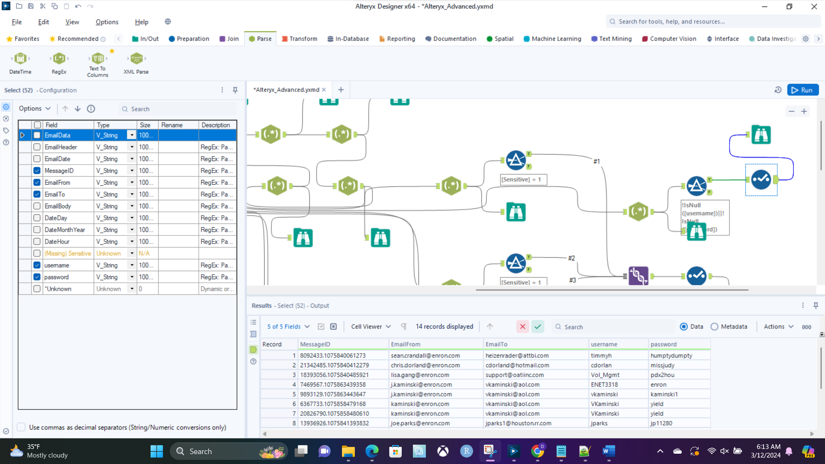

# Screenshot12

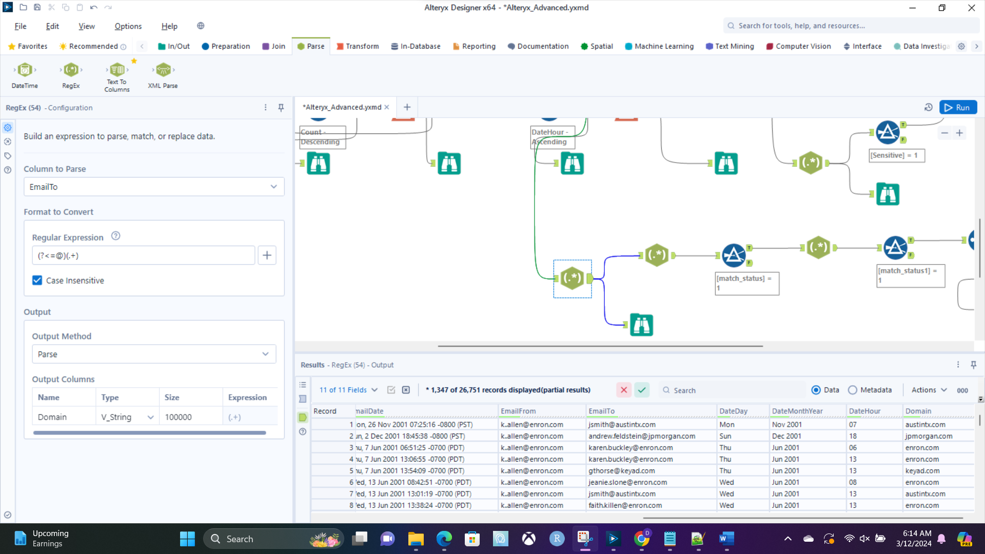

# Screenshot13

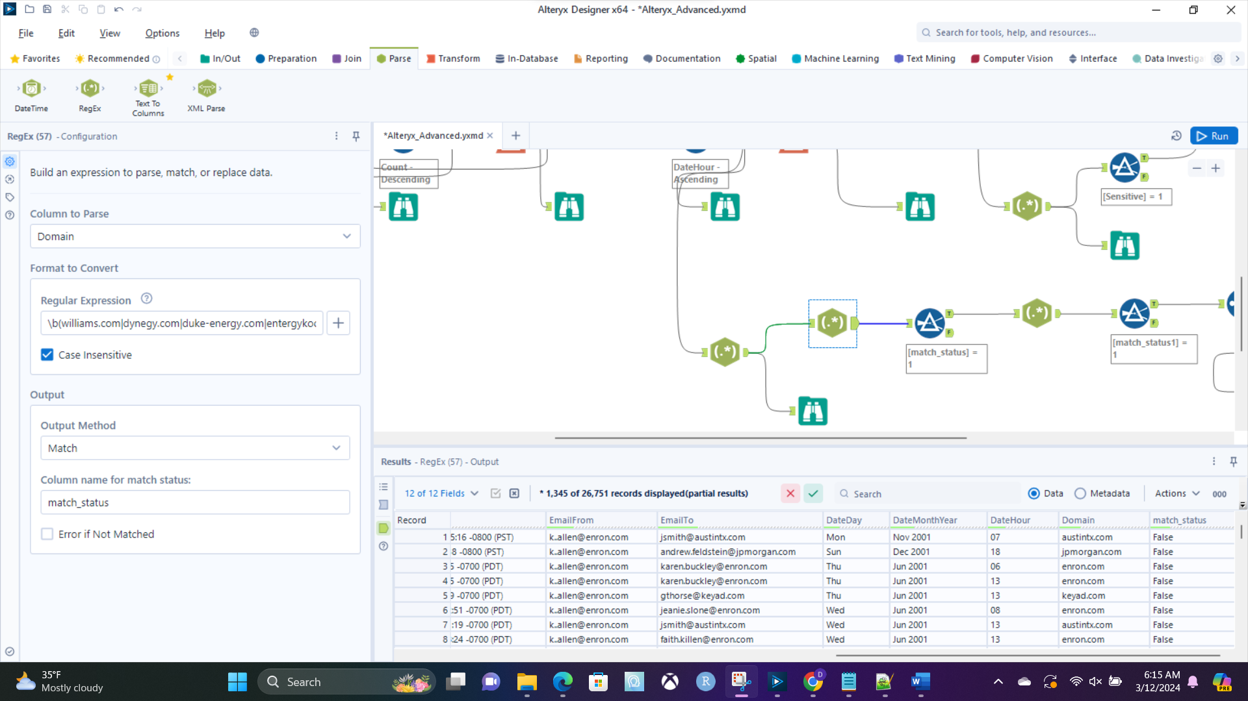

# Screenshot14

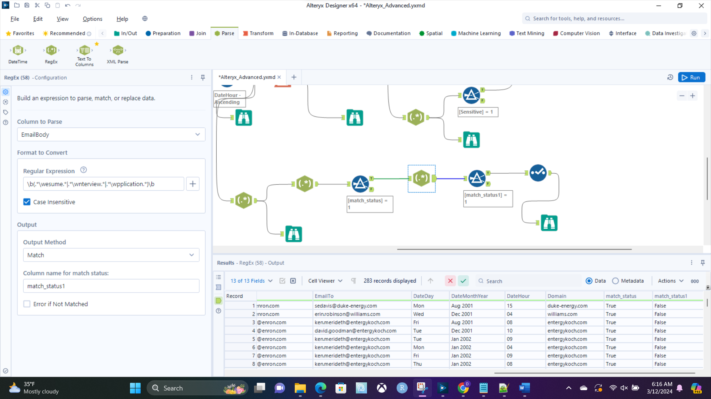

# Screenshot15

